What are Expressions? Name: _____________________ Per ______
Expression X  x-value answer  Table  What is the pattern? | Expression 2x  x-value result  What is the pattern? | Expression 2x+5  x-value Expression value  What is the pattern?
Expression -X  Input Output | Expression -2X + 5  Input Output | Expression x²  x-value output
What is the Pattern?
In your own words what are expressions?

Why do we use a table of values?

Use a graphing calculator.

Graphical Representation Name: _____________________ Per ______
Note: Set calculator ZOOM to ZFrac1/2.
Expression X  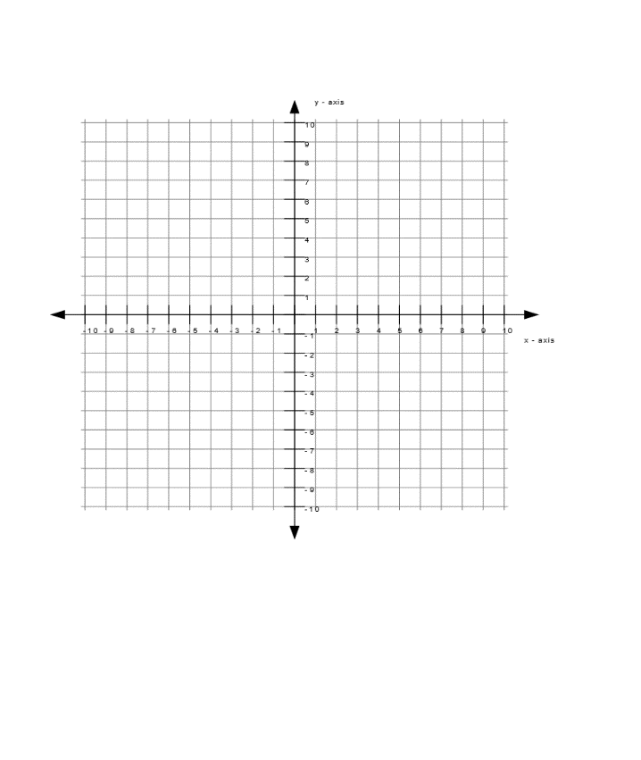  Sketch the Graph  Use the Trace key to compare the values to the table of values in pg 1.  What do you notice? | Expression 2x  Sketch the Graph  Use the Trace key to compare the values to the table of values in pg 1.  What do you notice? | Expression 2x+5  Sketch the Graph  Use the Trace key to compare the values to the table of values in pg 1.  What do you notice?
Expression -X  Sketch the Graph  Use the Trace key to compare the values to the table of values in pg 1.  What do you notice? | Expression -2X + 5  Sketch the Graph  Use the Trace key to compare the values to the table of values in pg 1.  What do you notice? | Expression x²  Sketch the Graph  Use the Trace key to compare the values to the table of values in pg 1.  What do you notice?
In your own words what is the relationship between the table of values and the corresponding graphs?

